GDPR Privacy Notice Template
Please find below a basic GDPR Privacy Notice.
You may need to develop a very specific GDPR Privacy notice for Children and Young People as the information should be easily understood.
It is useful to begin each policy and procedure that you develop with a small table to highlight what the policy is, who is responsible for its adoption and when it should be reviewed.
Policy Title
Responsible Officer
Retention Schedule
Implementation Date
Review Date
Version
Introduction to Privacy Notices
This privacy notice is an example that was generated using the ICO website, which you to can use to generate a privacy notice. Before you do this, it is worth understanding what will be in it and why it’s included in order to be able to select the right options for you privacy notice.
Create your own privacy notice | ICO
Generated Privacy Notice Example
The first section is your contents allowing the reader to get to the section they want to see quickly.
Customer Privacy Notice
This privacy notice tells you what to expect us to do with your personal information.
- Contact details
- What information we collect, use, and why
- Lawful bases and data protection rights
- Where we get personal information from
- How long we keep information
- Who we share information with
- How to complain
Next is your contact details so that people know how to contact you should they have a GDPR issue.

Contact details

Post: 123 Test Street, Test Town, Testishire TE5 5TS

Telephone: 0123456789

Email: Mr.Test@Test.org.uk
The next section lists all of the data that you collect and use and the purpose of collecting that information. Be sure to:
- List ALL Data Sets you hold. (All the information you collect)
- List all the uses of that data (e.g. Service Delivery, Marketing, Volunteer/employment information, Fundraising)
Be aware that below is just an example and that the list provided does not exhaust all possible options.

What information we collect, use, and why
We collect or use the following information to provide services and goods, including delivery and third party referrals:
- Names and contact details
- Gender
- Pronoun preferences
- Addresses
- Date of birth
- Emergency contact details
- Next of kin details
- Photographs or video recordings
- Information about care needs (including disabilities, home conditions, dietary requirements and general care provisions)
- Information about support requirements
- Website user information (including user journeys and cookie tracking)
We also collect or use the following information to provide services and goods, including delivery and third party referrals:
- Racial or ethnic origin
- Religious or philosophical beliefs
We collect or use the following information to receive donations or funding and organise fundraising activities:
- Names and contact details
- Addresses
- Payment or banking details
- Donation history
- Tax payer information (for Gift Aid purposes)
We collect or use the following personal information for service updates or marketing purposes:
- Names and contact details
- Addresses
- Marketing preferences

Lawful bases and data protection rights
This section contains a recap of the publics data protection rights. These rights are laid clearly on the ICO website and the links included within this section take you to the relevant pages to find out more information about each right.
Under UK data protection law, we must have a “lawful basis” for collecting and using your personal information. There is a list of possible lawful bases in the UK GDPR. You can find out more about lawful bases on the ICO’s website.
Which lawful basis we rely on may affect your data protection rights which are in brief set out below. You can find out more about your data protection rights and the exemptions which may apply on the ICO’s website:
- Your right of access - You have the right to ask us for copies of your personal information. You can request other information such as details about where we get personal information from and who we share personal information with. There are some exemptions which means you may not receive all the information you ask for. You can read more about this right here.
- Your right to rectification - You have the right to ask us to correct or delete personal information you think is inaccurate or incomplete. You can read more about this right here.
- Your right to erasure - You have the right to ask us to delete your personal information. You can read more about this right here.
- Your right to restriction of processing - You have the right to ask us to limit how we can use your personal information. You can read more about this right here.
- Your right to object to processing - You have the right to object to the processing of your personal data. You can read more about this right here.
- Your right to data portability - You have the right to ask that we transfer the personal information you gave us to another organisation, or to you. You can read more about this right here.
- Your right to withdraw consent – When we use consent as our lawful basis you have the right to withdraw your consent at any time. You can read more about this right here.
This is a reminder for both you and anyone who is concerned about there personal data that they can make Subject Access Requests. You have ONE month to provide the information around the request.
If you make a request, we must respond to you without undue delay and in any event within one month.
To make a data protection rights request, please contact us using the contact details at the top of this privacy notice.

Our lawful bases for the collection and use of your data
This section lays out the lawful basis (on what grounds) you keep data within the confines of the law and how that data was obtained. Here it lists that consent has been given. However it may be that you have received data in the following ways:
Contract – To enter into or comply with a contract.
Legal obligation – Complying with the law.
Legitimate interest - Collecting or using the information because it benefits the person, our organisation or someone else, without causing an undue risk of harm to anyone.
Vital interests - Information is needed when someone’s physical or mental health or wellbeing is at urgent or serious risk.
Public task – We have to collect or use the information to carry out a task laid down in law.
Be clear about how you came across data and how you are justifying collecting it.
Our lawful bases for collecting or using personal information to provide services and goods, including delivery and third party referrals are:
- Consent - we have permission from you after we gave you all the relevant information. All of your data protection rights may apply, except the right to object. To be clear, you do have the right to withdraw your consent at any time.
Our lawful bases for collecting or using personal information to receive donations or funding and organise fundraising activities are:
- Consent - we have permission from you after we gave you all the relevant information. All of your data protection rights may apply, except the right to object. To be clear, you do have the right to withdraw your consent at any time.
Our lawful bases for collecting or using personal information for service updates or marketing purposes are:
- Consent - we have permission from you after we gave you all the relevant information. All of your data protection rights may apply, except the right to object. To be clear, you do have the right to withdraw your consent at any time.

Where we get personal information from
This is a list of the places that you collect the data. List all of the places that you receive personal information and keep this list up to date.
- Directly from you
- Charities or voluntary sector organisations

How long we keep information
This section is the only section that is not completed by the ICO’s Policy generator. You are required to develop your own retention schedule. A retention schedule is a document that outlines what data you hold and how long you will keep it for.
In the below example they have listed the type of record how long it is to be kept for and where. Documenting where the information is can help keep the data accessible but also safe so that it is not lost or accidentally altered.
The reason for keeping the data (On what lawful basis you need to hold the data) and how it needs to be disposed of when it is due for deletion. If it is a digital document how do you ensure that the information is removed. If it is paper what mechanism do you have for safely disposing of it.
Listing this data not only helps you keep track of your responsibilities but also shows that you care for the information you have been entrusted with.
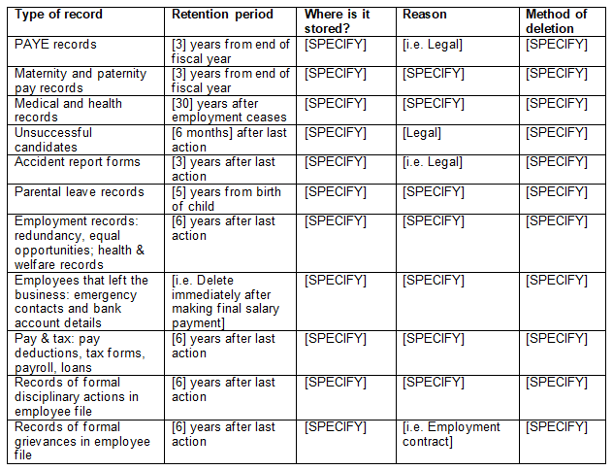

Who we share information with
Make sure to list any party who is not part of your organisation that you share data with, this can be contracted professionals, sessional workers, other organisations or even research studies. Be sure to give people the option to opt out of things they are not comfortable with.

Others we share personal information with
- Charities and voluntary organisations
- Professional advisors

How to complain
This information lays out how a complaint can be made to the ICO if someone is unhappy with how you are handling their data. It is important that this information is readily available to keep you complaint.
If you have any concerns about our use of your personal data, you can make a complaint to us using the contact details at the top of this privacy notice.
If you remain unhappy with how we’ve used your data after raising a complaint with us, you can also complain to the ICO.
The ICO’s address:
Information Commissioner’s Office
Wycliffe House
Water Lane
Wilmslow
Cheshire
SK9 5AF
Helpline number: 0303 123 1113
Website: https://www.ico.org.uk/make-a-complaint

Last updated
Mark down when this was last updated. It may even be worth keeping and maintaining a change log outlining when any changes have been made and what date they came into force in order to record how changes may effect people.
Additional Information
If you want any more information about GDPR or want to see our step by step guild head to our website for more resources. www.wcvs.org

